Moodle-OBE integration troubleshoot
Case 1: Ensure that advanced grading (marking guide / rubric) is used. The integration WILL NOT work without advanced grading. This means you must no use simple direct grading.
Case 2: Ensure that the marking guide / rubrics are used. Do not override the marks or upload marks from Excel as they will cause issues when exporting to OBE. Below is what happens when you have advanced grading setup but do not use it:
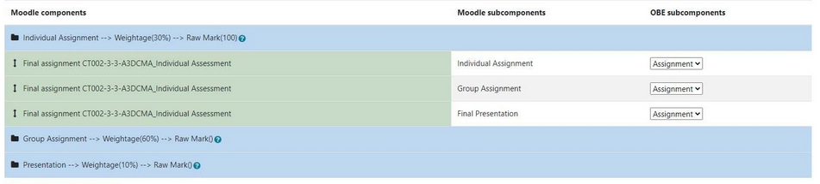
No subcomponents will be available
If you override the marks, it will be highlighted as yellow in the gradebook. Doing so will cause issues when exporting marks to OBE:
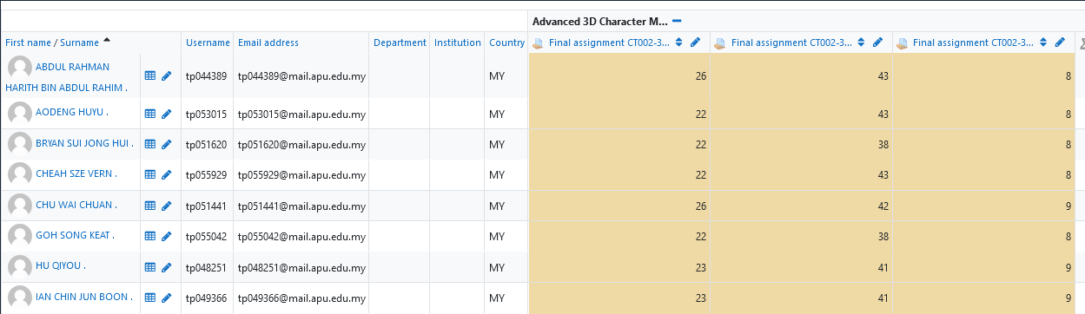
Do not do this. If you want to rectify the marks of a student, please regrade them accordingly.

Case 3: If you do not find a particular student’s name when exporting marks, please check to ensure that the lecture class code is assigned to them in the Participants tab.

